Kaitlin Kimberling

Kristina Ming

E155 Final Project

Final Project Proposal

**Project Overview**

In this project we will create a device to read a person’s pulse through their finger and report the pulse to a display, such as a seven-segment LED display. The user should be able to place their finger on top of a sensor mounted to the breadboard. The output of the sensor will be filtered and amplified before being sent to the PIC for processing. The PIC will interpret the input as a rate. This rate will be sent to the FPGA, which will show the number on the display.

**System Overview**

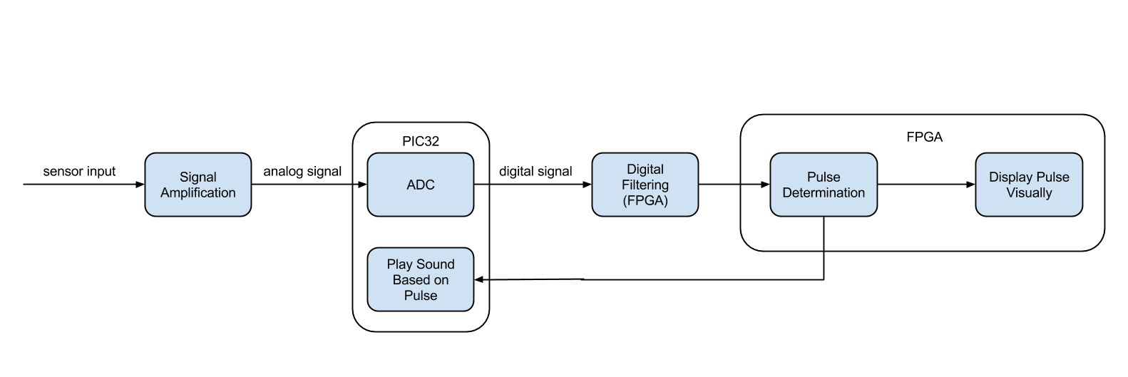

**Subsystem Plans**

*Sensor*

The system needs a sensor that can detect pulse. This can be implemented using an infrared LED and a light-sensitive sensor such as a photodiode or phototransistor. A fingertip placed over an infrared LED will reflect different amounts of light depending on the volume of blood inside the arteries. A light sensor can detect the amount of light that is reflected. Fluctuations in the electrical signal based off of this light detection correspond to heart rate. The LED and the photo-detector must be located close to each other, and the user should place their fingertip on top of both sensors.

*Amplification*

The changes in reflectivity detected by the sensor as blood pulses will be small, so the electrical signal from the sensor will need to be amplified to be useful. This can be done using an operational amplifier.

*Signal Processing*

The ADC on the PIC32 will be used to convert the analog sensor signal to a digital signal. The PIC will extract the heart rate and send it via SPI communication to the FPGA.

*Filtering*

The signal will be filtered digitally on the FPGA. Ideally, a bandpass filter will be used to eliminate noise. This will likely be an FIR filter.

*Display*

The FPGA will control a seven-segment display which will show the three digits of the pulse.

*Sound*

The PIC will turn the pulse into some auditory signal, such as an audible heartbeat or a note.

**Deliverables**

A system will be created that measures and displays a user’s heart rate. The system will also play a sound based on the heartbeat. The PIC and the FPGA will use SPI to communicate.

**Stretch Goals**

If the above deliverables get completed, we will try to add a system to display the analog heartbeat signal.

**Required Materials/Budget**

The system will require basic electrical components such such as op amps, capacitors and resistors which are available in the engineering stockroom. Additional parts that may have to be purchased are listed in the table below.

|  |  |  |  |
| --- | --- | --- | --- |
| **Item** | **Quantity** | **Price ($)** | **Comments** |
| Infrared LED | 1 | 5 | SparkFun or Digi-Key |
| Photodiode | 1 | 5 | SparkFun or Digi-Key |
| Material to isolate LEDs | 1 | 5 |  |